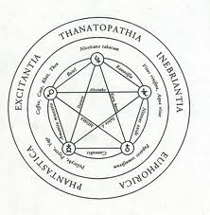 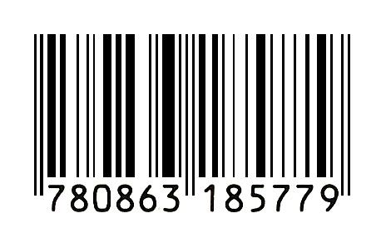 

***Alchemy/Schmalchemy***

***Manifestation III***

Fabric, Bradford

24 Nov 2012

 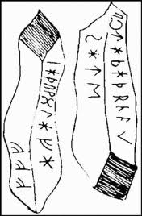  

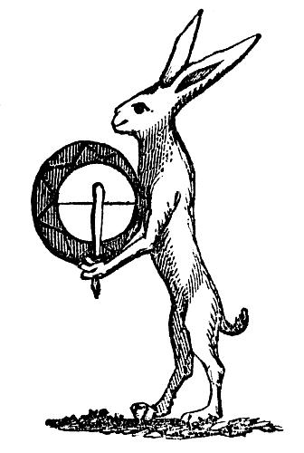 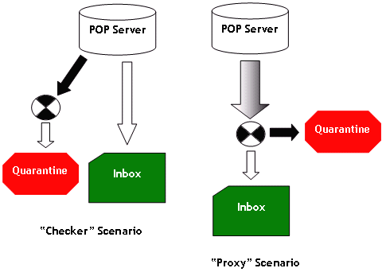  

   

***Magna Reductio***

***Phase 2*** of ***Alchemy/Schmalchemy - Manifestation III*** works with reverberations from a previous performance – *Node/Flow/Mass (Disaster Box*) – co-curated by Geoff Bright, Walt Shaw, Gillian Whiteley and Matt Harling. The event carried out a sonic exploration of processes of *massification* through a mobile occupation – with over 60 improvising performers - at the vast former steel works, Magna, near Sheffield. *Magna Reductio* conjures an alchemical reversal of scale through *minimisation* and employs close- microphone field recordings made recently in tunnels beneath the Magna site by Brighton-based sound artist Danny Bright.

**Geoff Bright**, **Walt Shaw** and **Gillian Whiteley** have been working as *Alchemy/Schmalchemy* since 2009.

***Geoff Bright*** (aka ***oneoftheroughs****)* messes about on saxophones, homemade 3-string electric guitar and voice. He also likes to play around in public with theory that he can’t quite understand in the hope that somebody might understand it for him.

***Walt Shaw*** is a percussionist, visual and performance artist, based in the Midlands. His preoccupations are in free improvisation, experimental music and collaborations with other disciplines, especially contemporary dance, visual and live art. He has performed throughout the U.K. and in Europe.

***Gillian Whiteley*** (aka ***bricolagekitchen***) operates across critical boundaries, ruminating on politics, pranks and praxis, creating *Pan*-demonium from time to time (New York 2009, Berlin 2010) and can be found making a racket on a narrowboat on the Trent & Mersey or conjuring tree spirits in Correze, France. [www.bricolagekitchen.com](http://www.bricolagekitchen.com)

   

***Alchemy/Schmalchemy - Manifestation III***

*Zen brushing meets distilled Magna meets numbo-jumbo*

***Alchemy/Schmalchemy*** conjures a disruptive oscillatory space of mischief, a laboratory of possibility. It plays with the idea of ***alchemy*** as transformation of value and parodies magic, authenticity and artifice as its unconscious fabrications. Becoming intense, becoming animal, becoming imperceptible, becoming charlatan, becoming shaman, becoming sham…

A becoming-animal always involves a pack, a band, a population, a peopling, in short, a multiplicity. We sorcerers have always known that. Gilles Deleuze and Felix Guattari, *A Thousand Plateaus*

**Geoff**

Breath, bellows, sound, moving air, awakes us from sleep. We search for the spark, the dream, the elixir. The spark of light is always there. We orbit, we sing, we dance, we play, we experiment, we collude in our joy of the search. Alchemical processes move through a series of cryptic levels. The intense yearning, the craving, the striving, MUST lead to transmutation, to a final sublimation

**Walt**

Something must happen, something MUST HAAAAPPEEEEN...Ugge Ugge Ugge! *Dutch Provo* chant, 1960s Who then is making such a racket at the door? Michel Serres, *The Parasite*

**Gill**