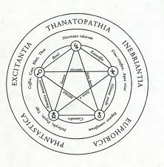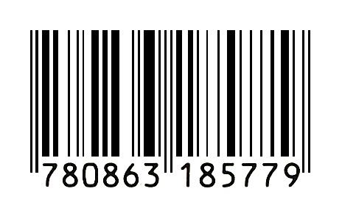

Wright of Derby meets Provo meets

Deleuze and Guattari meets chemistry-set in…

***Alchemy/Schmalchemy***

Last Saturday Night Live, Bank Street Arts, Sheffield

28th July 2012

***Alchemy/Schmalchemy*** conjures a disruptive oscillatory space of mischief, a laboratory of possibility. It plays with the idea of ***alchemy*** as transformation of value and parodies magic, authenticity and artifice as its unconscious fabrications. Becoming intense, becoming animal, becoming imperceptible….becoming shaman, becoming charlatan…becoming sham…

Something must happen, something MUST HAAAAPPEEEEN...Ugge Ugge Ugge! *Dutch Provo* chant, 1960s / Who then is making such a racket at the door? Michel Serres, *The Parasite* - Gill

The spark of light is always there. We orbit, we sing, we dance, we play, we experiment, we collude in our joy of the search. Alchemical processes move through a series of cryptic levels. The intense yearning, the craving, the striving, MUST lead to transmutation, to a final sublimation – Walt

A becoming-animal always involves a pack, a band, a population, a peopling, in short, a multiplicity. We sorcerers have always known that. Deleuze and Guattari, *A Thousand Plateaus -* Geoff

**Geoff Bright**, **Walt Shaw** and **Gillian Whiteley** have been working together on ***Alchemy/Schmalchemy*** since 2009. See <http://www.bricolagekitchen.com/styled-2/styled-20/index.html>

