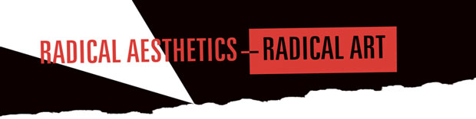

Radical Footage: Film and Dissent

Free event: Friday 9th March 2012 – 11am – 7pm
The Space, Nottingham Contemporary
Experimental film has played a significant role in contesting the political status quo from Lenin's early C20 declaration that cinema was the most revolutionary artform to DIY footage of the Arab Spring and anti-capitalist occupations. Locally and globally, film is being used to provoke, agitate, ask questions and generate new politicized communities.

A selection of short radical films and commentaries will explore the potential of film to contribute to social-political change. The day’s debate will be initiated by Oliver Ressler’s introduction to his film What is Democracy? Discussions will be led by Esther Leslie (Birkbeck University of London), Martin O’Shaughnessy (Nottingham Trent University) and Gary Anderson (Liverpool Hope University/Free University of Liverpool.

To book a place visit the Nottingham Contemporary website: http://ncradicalaesthetics.eventbrite.com/?ebtv=C

RadicalAesthetics-RadicalArt project is based at Loughborough University School of the Arts. Visit the RaRa website at
http://www.lboro.ac.uk/departments/sota/research/groups/politicised/rara.html
For further information contact RaRa organisers:
Jane Tormey: J.Tormey@lboro.ac.uk Gillian Whiteley: G.Whiteley@lboro.ac.uk

